Grand Cathedral
Game Construction
Copyright 2020 © Jay Altemus

Cathedral is a very entertaining and challenging board game for two players. Grand Cathedral is an expanded version of the original Cathedral game. This larger version of the game is fun to play as well as a beautiful conversation piece when on display.

As you read through these instructions, keep in mind that part of the beauty of the game comes from the shapes of the various buildings and bridges. Building the game requires attention to detail but the construction is well within the skills of the beginning woodworker.

Tool and supply checklist:
□ Table saw with a 1/8” thick blade | □ Pencil
□ Band saw | □ Compass
□ 1/4” wood chisel | □ Protractor
□ Tape measure | □ Masking Tape
□ Builders square | □ Eye protection and face mask
□ Wood glue | □ Wood finish and brush
□ Sandpaper | □ Wood stain and brush (optional)

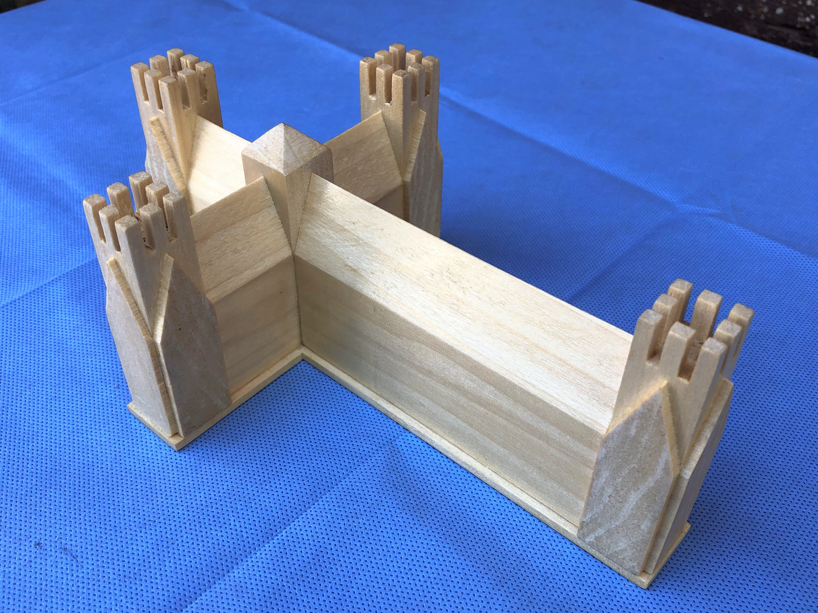
Wood Selection:
Player game pieces – Choose a light colored wood to make one set of player pieces and a dark wood for the other player pieces. You could make all pieces from a light colored wood and then stain one set darker instead. The contrast in color must be obvious. I chose WENGE for the dark pieces and solid RED OAK for the light pieces.

Game piece bases – Use the same wood for the base pieces that you used for the game pieces. I used WENGE and RED OAK for the game pieces and ASH for the Cathedral.
Each game piece has a point value based on the number of squares it would occupy on the game grid. Write the point value and the game piece letter(s) on the bottom of each assembled game piece before applying the final wood finish. I used a satin polyurethane finish on all game pieces and the game board.

Cathedral game piece and base – The Cathedral piece should be lighter in color than all the other game pieces. I used ASH to make my Cathedral and Cathedral base.

General Cutting Instructions:
Most of the game pieces can be made using a table saw. Reference the tables so you can cut similar pieces with minimal waste.

Staying Organized – Label pieces with a pencil as you cut them. Store same size pieces in labeled zip-loc bags. Refer to the tables when cutting pieces. Each table lists all the pieces with a similar size and shape so you can cut multiple pieces at the same time.

Game Pieces
Use 3/4” thick wood. Most towers and spires are 1” wide X 3/4” thick. Houses are also 3/4” thick but vary in length.

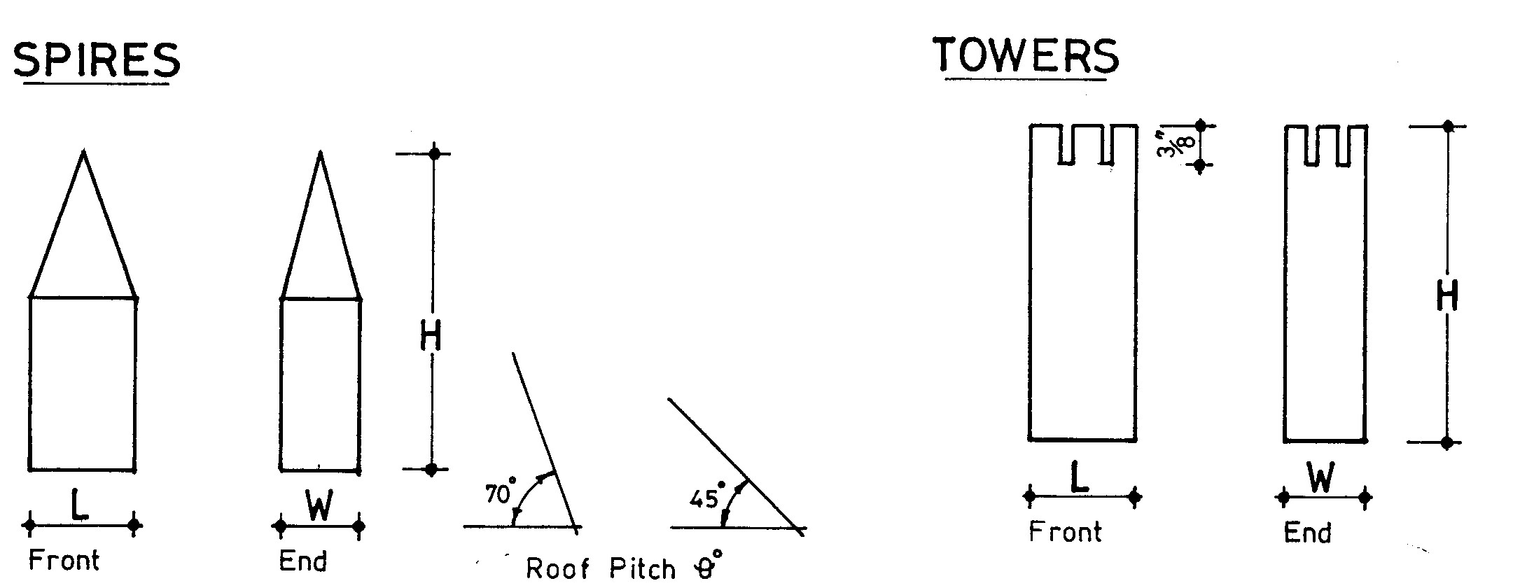

Towers – Choose a board 3/4” thick X 6” wide and with grain that is at least 3” long. With the wood grain vertical to the table, cut two evenly spaced kerfs 3/8” deep in the end grain of the board. Verify the kerfs are evenly spaced and perfectly vertical before you finalize the fence and blade positions. Next, rip the board into 1” wide pieces. The tower ends still need two more kerfs. Stack and clamp several towers together and cut two more evenly spaced kerfs at 90 degrees to the original cuts. Cut out the center turret with a wood chisel. Trim each piece to the proper height. Cut the bottom of the piece last to obtain the proper height.

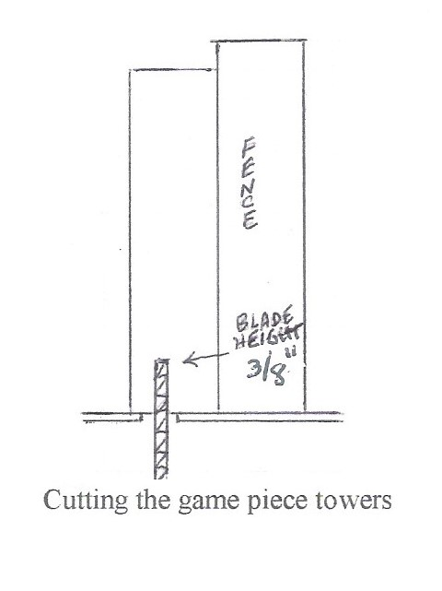

Spires: A special jig is used to cut spires. All spires have a vertical wood grain, Rip a 3/4” thick board into 1” wide strips that are at least 3” long. Draw an X from corner to corner on one end of each piece. The center of the X mark is your guide. Use the jig to cut a 70 degree angle on two sides to form a roof peak. The correct cutting angle for the final two cuts is made by fine adjusting the miter guide and jig angle so roof edges meet at the corners of the spire and the point is centered. Trim each piece to the proper height.

Make the jig by cutting a piece of scrap wood as shown in the diagram below. Glue piece A and B together as shown and screw or glue a brace piece across the joint as shown in the next diagram.
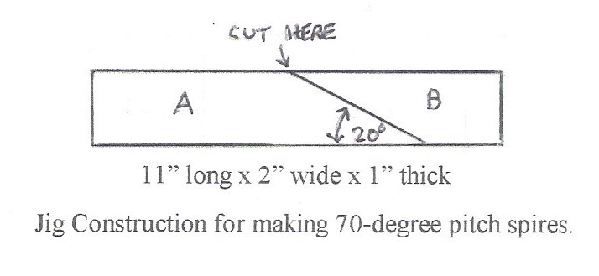

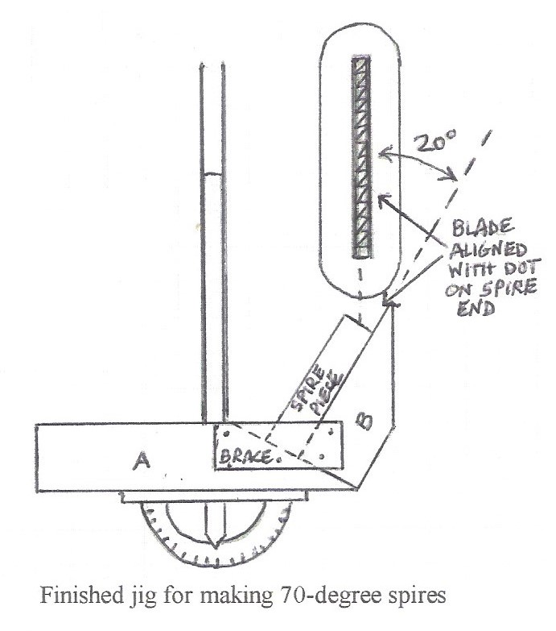
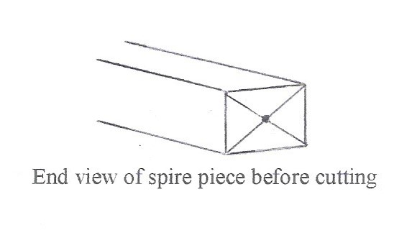
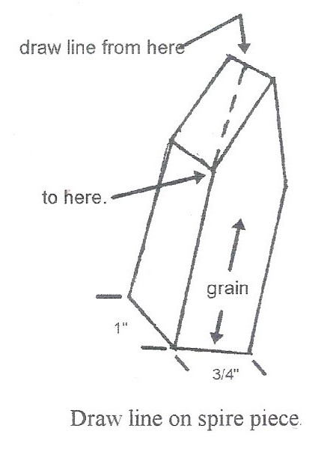
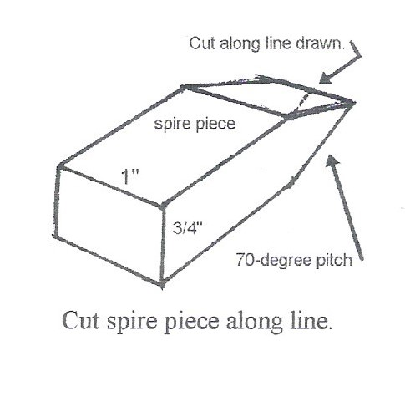
Houses – All house pieces are cut with the wood grain horizontal. Cut a 70 degree or 45 degree house peak on the edge of a 3/4” board by ripping one edge of the board TWICE with the table saw blade set at the proper angle. Confirm a precision cut down the middle of the edge of a piece of 3/4” scrap wood first. A precise cut will put the peak in the center of the board edge. Cut the other edge of the board to obtain the proper height. Crosscut the board to make the houses the correct length.

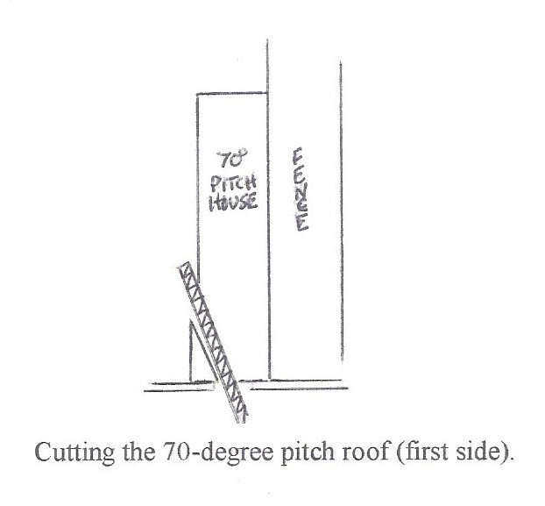

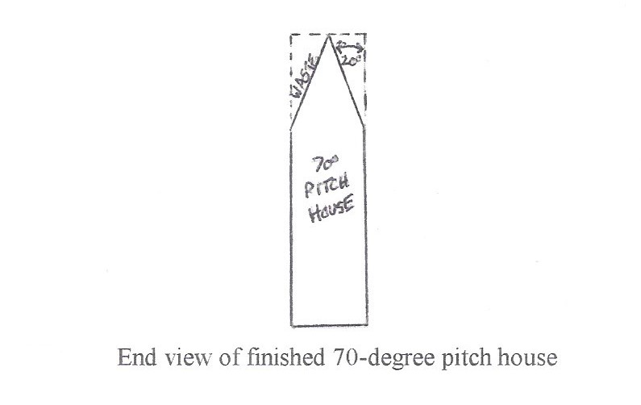

Game Board Construction
My game board base is 23” square. You can make your game board larger if you want. Choose wood light enough so players can easily see the grid on the board. I cut a piece of 3/4” thick premium OAK plywood to a perfect 22 + 1/2” square and then added 1/4” thick strips of decorative trim to the edges to hide the plywood layers. That’s how I ended up with a 23” X 23” square game board.

Draw a 20” X 20” grid in the exact center of the plywood game base. Precision is important. The grid must dark enough to be visible after applying a wood finish to the game board. My grid was marked using a dark pencil.

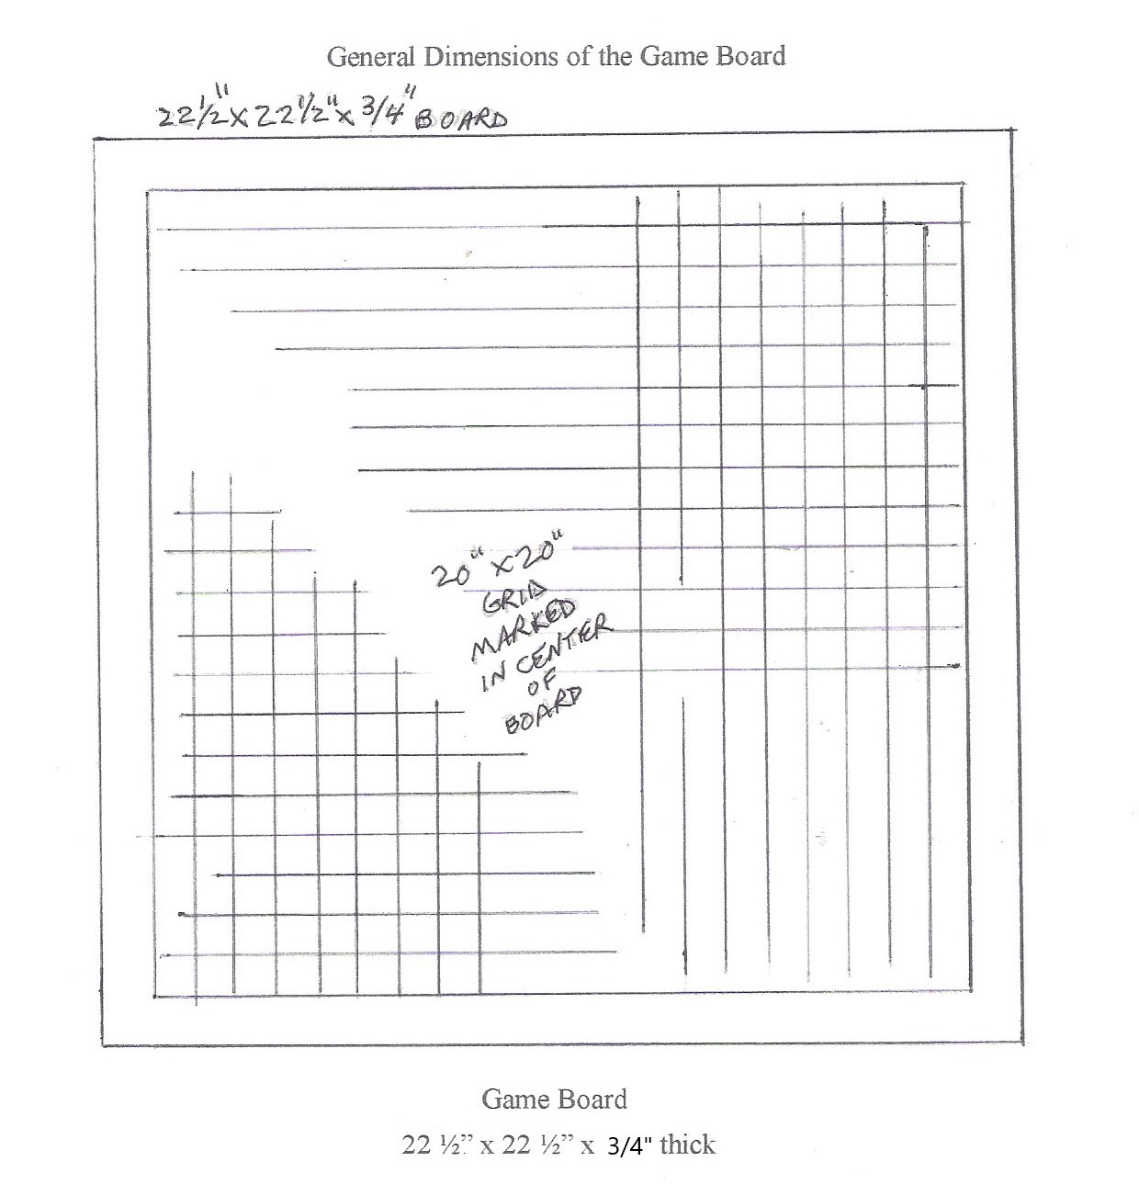
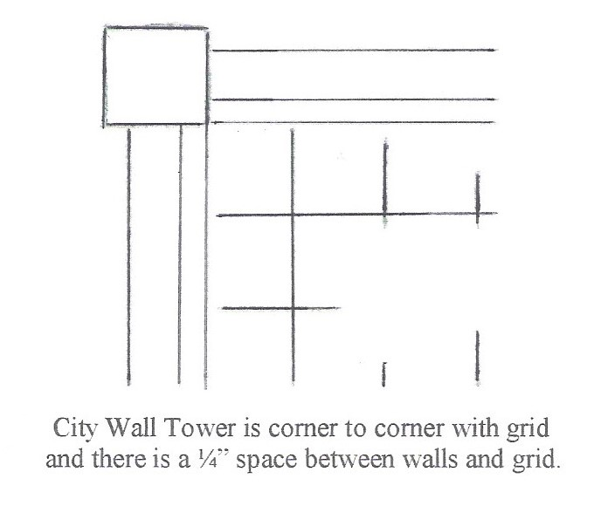
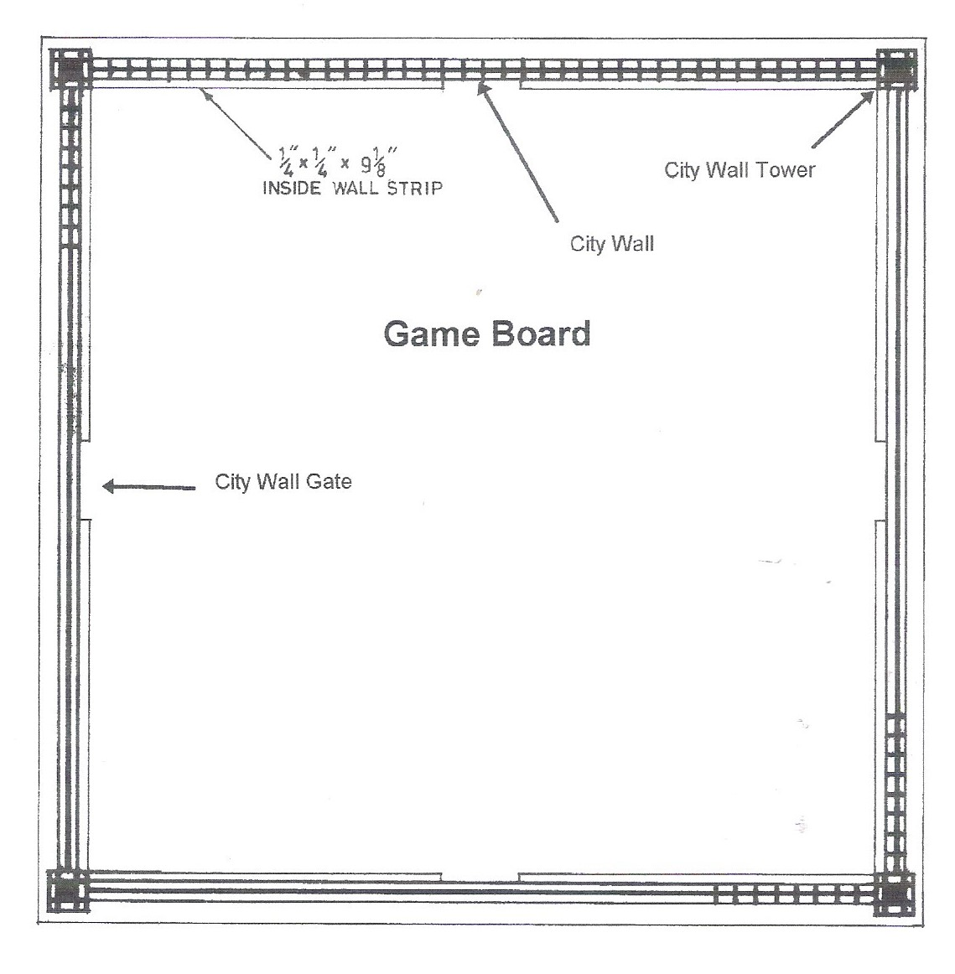
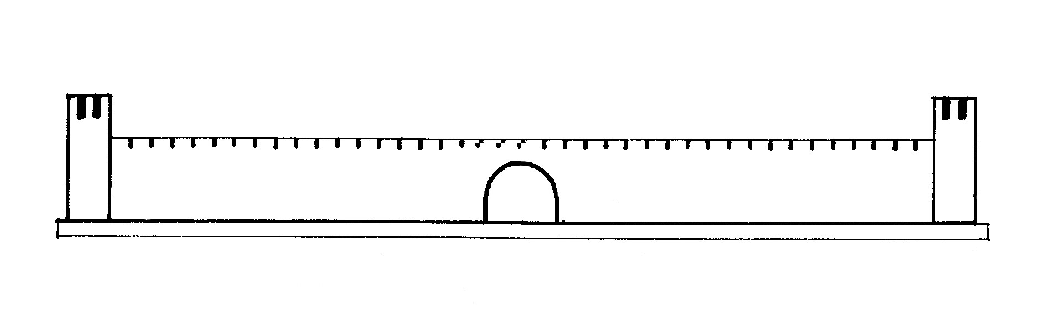

City Walls – Game board walls are cut so the wood grain is horizontal. The city walls are made from 1/2” thick solid RED OAK. Cut a 1/2” thick board to make four 20” X 2” walls with horizontal grain. Stack all 4 walls together with a piece of scrap at the back and tape them together as a neat stack. .Mark the top edge every 1/2” and cut a 1/8” wide X 3/16” deep kerf at each mark to create turrets along the top of the walls. Next, cut a 3/16” deep X 3/16” wide kerf perfectly centered along the top edge of each city wall. The gates in each wall are made by cutting a 1 + 3/4” diameter hole centered 1/2” above the bottom edge of the wall. Cut the gate in the exact center of each wall. Trim gate walls to be vertical below the 1/2” mark.

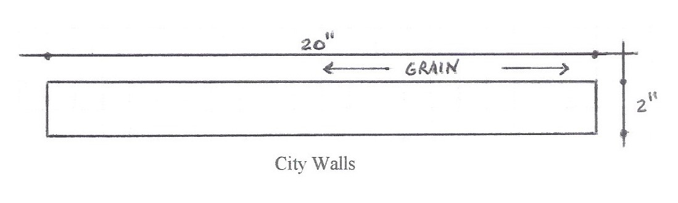
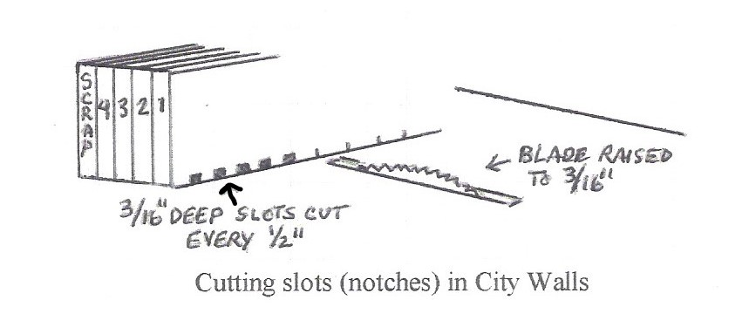
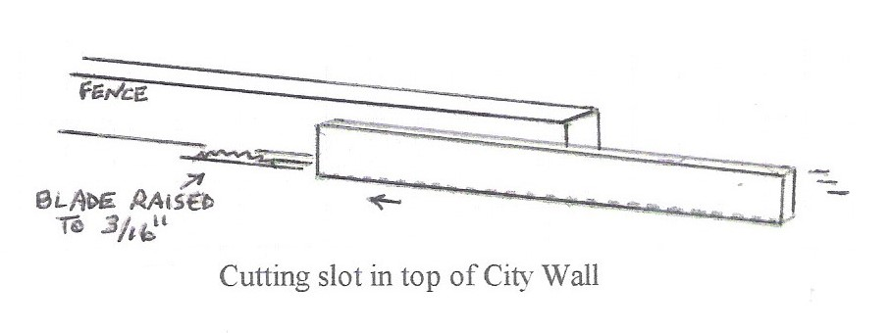
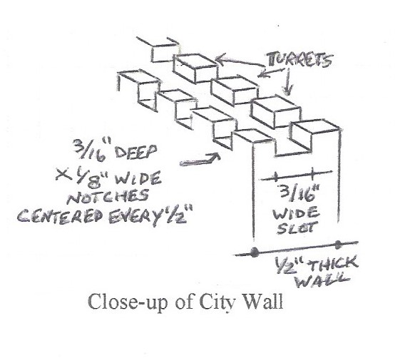

City Wall Gates – Gates are cut in the center of each city wall using a hole saw or band saw. The center of the 1 + 3/4” diameter circle is 1/2” above the bottom of the wall. Trim the lower half of the circle so it is 90 degrees and vertical to the game board. A 1/4” X 1/4” strip of wood will be glued along the inside of the wall as shown below.
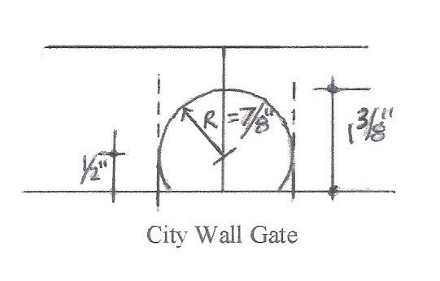
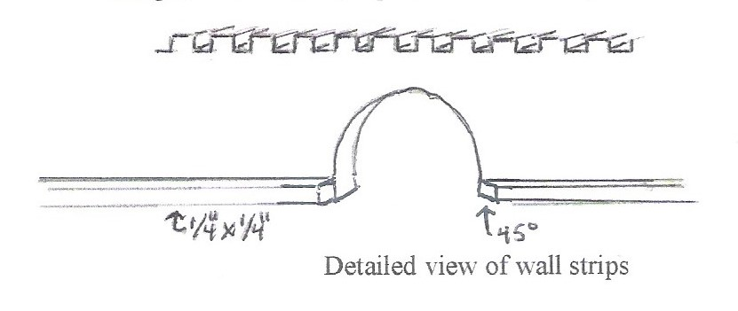
City Wall Towers – The city wall towers are 1” X 1” with a vertical grain. Cut tower turrets first. Cut the bottom of the piece last to obtain the proper height. I made mine by gluing 3/4” RED OAK together and then trimming them to 1” X 1” pieces that are at least 3” tall with a vertical wood grain. Cut four 3/8” deep X 1/8” wide kerfs in the top of each tower piece to make the turrets. Cut out the center turret with a wood chisel. Trim each piece to make a 1” X 1” tower that is 3” tall with a vertical wood grain.

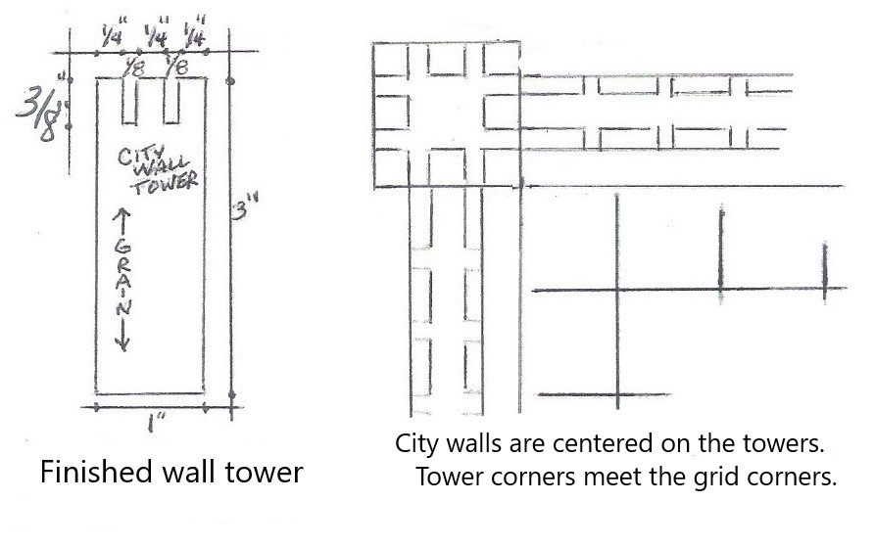

I glued a city tower on each end of two city walls and let the glue dry. The remaining 2 city walls were glued to the city wall towers to form a perfect square. Done correctly, the inside corners of the city wall towers will touch the corners of the grid on the playing board. After the glue dries, the city wall and towers can be screwed to the game board base with stainless wood screws. Add 1/4” X 1/4” strips along the inside base of each city wall. Miter the end of the strip 45 degrees where the strip meets the city wall gate.

Playing Piece Bases – These pieces are made by cutting a 31/32” wide X 1/8” thick strip to make the different length base pieces shown in the chart. Pieces are glued together to form the shapes shown below. Towers, spires, bridges, etc are glued on top of each base piece.

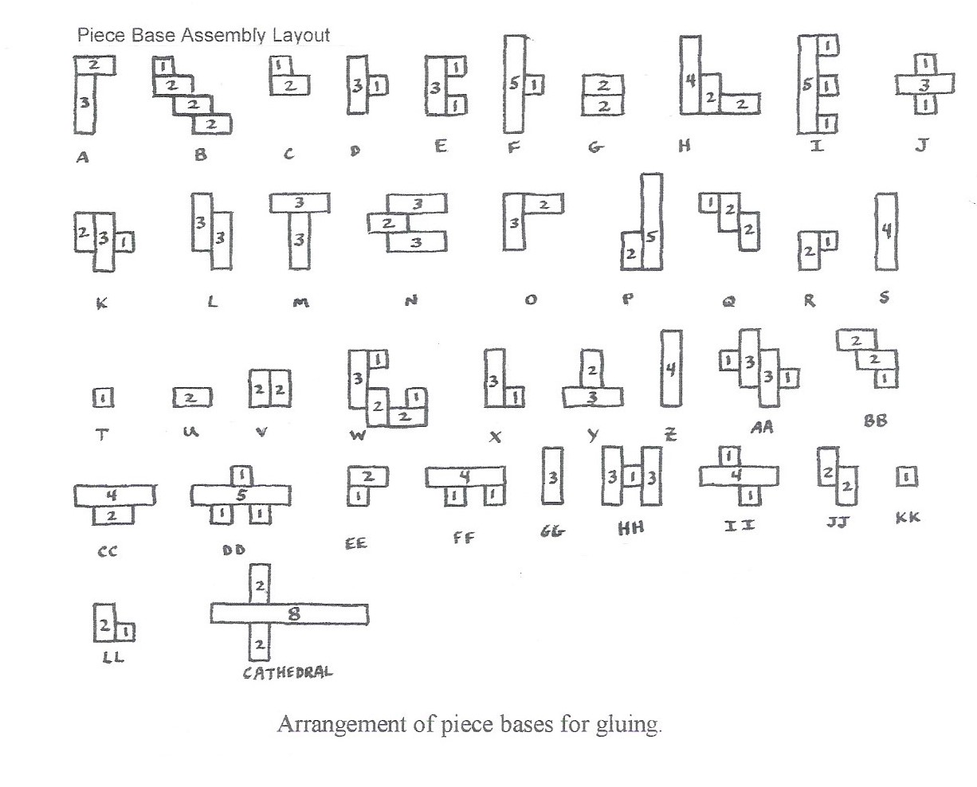

Playing Piece Base Strips

31/32” wide  strips  X  1/8” thick | Piece Length | # of pieces | Pieces using these strips
31/32” wide  strips  X  1/8” thick | 8” | 1 | Cathedral
31/32” wide  strips  X  1/8” thick | 5” | 4 light  4 dark | F, I, P, DD
31/32” wide  strips  X  1/8” thick | 4” | 6 light  6 dark | H, S, Z, CC, FF, II
31/32” wide  strips  X  1/8” thick | 3” | 20 light  20 dark | A, D, E, J, K, L, L, M, N, O, W, X, Y, AA, GG, HH
31/32” wide  strips  X  1/8” thick | 2” | 30 light  30 dark | A, B, C, G, H, K, N, O, P, Q, R, U, V, W,  Y, BB, CC, EE, JJ, LL, Cathedral
31/32” wide  strips  X  1/8” thick | 1” | 32 light  32 dark | B, C, D, E, F, I, J, K, Q, R, T, W, X,  AA, BB, DD, EE, FF, HH, II, KK, LL
31/32” wide  strips  X  1/8” thick | Total  # pieces | 185 | Refer to base piece assembly layout for gluing.
Cathedral Construction Reference Tables
Copyright 2002 © Jay Altemus

These charts tell you how many pieces of each size to cut. Store same size pieces in bags to stay organized.
TOWERS

TABLE #1
Game Board City Wall Corner Towers
1” wide X 1” thick | Tower height | # of pieces
1” wide X 1” thick | 3” tall | 4

TABLE #2
Game Piece Towers
1” wide  X  3/4” thick | Tower height | # of pieces  dark wood | # of pieces  light wood | Piece Letter  (one dark and one light tower for each letter )
1” wide  X  3/4” thick | 3” | 8 | 8 | A, B, B, H, P, P, BB, BB
1” wide  X  3/4” thick | 2 + 1/2” | 9 | 9 | F, F, H, H, V, V, DD, DD, LL
1” wide  X  3/4” thick | 2” | 11 | 11 | E, E, H, J, J, AA, AA, CC, CC, FF, II
1” wide  X  3/4” thick | 1 + 1/2” | 3 | 3 | I, I, Y
1” wide  X  3/4” thick | Total  # pieces | 31 | 31

TABLE #3
Game Piece Towers  3/4” wide  X  3/4” thick | Tower height | # of pieces  dark wood | # of pieces  light wood | Piece Letter  (one dark and one light tower for each letter)
Game Piece Towers  3/4” wide  X  3/4” thick | 3” | 2 | 2 | O, HH
Game Piece Towers  3/4” wide  X  3/4” thick | Total  # pieces | 2 | 2

HOUSES
70 Degree Roof Pitch

TABLE #4
3” tall  X  3/4” thick | House Length | # of pieces  dark wood | # of pieces  light wood | Piece Letter  (one dark and one light house for each letter)
3” tall  X  3/4” thick | 2 + 3/4” | 2 | 2 | D, J
3” tall  X  3/4” thick | 1 | 3 | 3 | G, G, N
3” tall  X  3/4” thick | Total  # pieces | 5 | 5

TABLE #5
2 + 1/2” tall  X  3/4” thick | House Length | # of pieces  dark wood | # of pieces  light wood | Piece Letter  (one dark and one light house for each letter)
2 + 1/2” tall  X  3/4” thick | 3 + 3/4” | 1 | 1 | II
2 + 1/2” tall  X  3/4” thick | 2 + 3/4” | 2 | 2 | A, M
2 + 1/2” tall  X  3/4” thick | 2” | 4 | 4 | W, W, AA, AA
2 + 1/2” tall  X  3/4” thick | 1” | 4 | 4 | G, I, Q, Q
2 + 1/2” tall  X  3/4” thick | 3/4” | 1 | 1 | T
2 + 1/2” tall  X  3/4” thick | Total  # pieces | 12 | 12

TABLE #6
2” tall  X  3/4” thick | House Length | # of pieces  dark wood | # of pieces  light wood | Piece Letter  (one dark and one light house for each letter)
2” tall  X  3/4” thick | 2 + 3/4” | 3 | 3 | E, F, DD
2” tall  X  3/4” thick | 2” | 2 | 2 | O,O
2” tall  X  3/4” thick | 1 + 3/4” | 5 | 5 | C, R, X, FF, LL
2” tall  X  3/4” thick | 1 + 1/4” | 1 | 1 | FF
2” tall  X  3/4” thick | 1” | 9 | 9 | A, B, B, C, D, K, K, CC, CC
2” tall  X  3/4” thick | Total  # pieces | 20 | 20
HOUSES
70 Degree Roof Pitch

TABLE #7
1 + 1/2” tall  X  3/4” thick | Piece Length | # of pieces  dark wood | # of pieces  light wood | Piece Letter  (one dark and one light house for each letter)
1 + 1/2” tall  X  3/4” thick | 1 + 3/4” | 2 | 2 | EE, FF
1 + 1/2” tall  X  3/4” thick | 1” | 6 | 6 | K, K, Q, Q, AA, AA
1 + 1/2” tall  X  3/4” thick | Total  # pieces | 8 | 8

HOUSES
45 Degree Roof Pitch

TABLE #8
2” tall  X  3/4” thick | Piece Length | # of pieces  dark wood | # of pieces  light wood | Piece Letter  (one dark and one light house for each letter)
2” tall  X  3/4” thick | 2 + 3/4” | 1 | 1 | Y
2” tall  X  3/4” thick | 2” | 2 | 2 | H, H
2” tall  X  3/4” thick | 1” | 2 | 2 | CC, CC
2” tall  X  3/4” thick | Total  # pieces | 5 | 5

TABLE #9
1 + 1/2” tall  X  3/4” thick | Piece Length | # of pieces  dark wood | # of pieces  light wood | Piece Letter  (one dark and one light house for each letter)
1 + 1/2” tall  X  3/4” thick | 3” | 1 | 1 | P
1 + 1/2” tall  X  3/4” thick | 2” | 1 | 1 | M
1 + 1/2” tall  X  3/4” thick | 1” | 2 | 2 | F, R
1 + 1/2” tall  X  3/4” thick | Total  # pieces | 3 | 3

TABLE #10
1” tall  X  3/4” thick | Piece Length | # of pieces  dark wood | # of pieces  light wood | Piece Letter  (one dark and one light house for each letter)
1” tall  X  3/4” thick | 1” | 2 | 2 | Y, EE
1” tall  X  3/4” thick | 3/4” | 1 | 1 | KK
1” tall  X  3/4” thick | Total  # pieces | 3 | 3

SPIRES
70 Degree Roof Pitch

TABLE #11
1” wide  X  3/4” thick | Spire height | # of pieces  dark wood | # of pieces  light wood | Piece Letter  (one dark and one light spire for each letter)
1” wide  X  3/4” thick | 3” | 14 | 14 | G, K, K, M, P, V, V, W, W, BB, BB, HH, HH, II
1” wide  X  3/4” thick | 2 + 1/2” | 5 | 5 | W, W, DD, DD, DD
1” wide  X  3/4” thick | Total  # pieces | 19 | 19

TABLE #12
3/4” wide  X  3/4” thick | Spire height | # of pieces  dark wood | # of pieces  light wood | Piece Letter  (one dark and one light spire for each letter)
3/4” wide  X  3/4” thick | 3” | 1 | 1 | Q
3/4” wide  X  3/4” thick | 2” | 2 | 2 | W, BB
3/4” wide  X  3/4” thick | Total  # pieces | 3 | 3

SPIRES
45 Degree Roof Pitch

TABLE #13
1” wide  X  3/4” thick | Spire height | # of pieces  dark wood | # of pieces  light wood | Piece Letter  (one dark and one light spire for each letter)
1” wide  X  3/4” thick | 2 + 1/2” | 1 | 1 | P
1” wide  X  3/4” thick | 2” | 4 | 4 | HH, HH, HH, HH
1” wide  X  3/4” thick | Total  # pieces | 5 | 5

Cathedral Pieces
Wood for the Cathedral should be lighter than all the other wood pieces.

TABLE #14

Cathedral Towers
3/4“ wide  X  3/4“ thick | Tower height | # of pieces  very light wood
3/4“ wide  X  3/4“ thick | 3” | 4
3/4“ wide  X  3/4“ thick | Total  # pieces | 4

TABLE #15

Cathedral Center Spire with 45-degree pitch
3/4“ wide  X  3/4“ thick | Spire height | # of pieces  very light wood
3/4“ wide  X  3/4“ thick | 3” | 1
3/4“ wide  X  3/4“ thick | Total  # pieces | 1

TABLE #16
Cathedral Houses with 70-degree Pitch Roof
2.5” tall  X  3/4” thick | Piece Length | # of pieces  very light wood
2.5” tall  X  3/4” thick | 4 + 1/4” | 1
2.5” tall  X  3/4” thick | 1 + 1/4” | 3
2.5” tall  X  3/4” thick | 1/8” | 12
2.5” tall  X  3/4” thick | Total  # pieces | 16

Bridge Steps

TABLE #17
1/8” thick  X  1/2” wide | Step Length | # of pieces  dark wood | # of pieces  light wood | Piece Letter  (one dark and one light piece for each letter)
1/8” thick  X  1/2” wide | 4” | 2 | 2 | S, Z
1/8” thick  X  1/2” wide | 3” | 3 | 3 | S, Z, GG
1/8” thick  X  1/2” wide | 2 + 3/4” | 2 | 2 | N, N
1/8” thick  X  1/2” wide | 2 + 1/2” | 6 | 6 | L. L, N, N, N, GG
1/8” thick  X  1/2” wide | 2 + 1/4” | 4 | 4 | L, L, N, N
1/8” thick  X  1/2” wide | 2” | 7 | 7 | L, L, N, N, S, Z, GG
1/8” thick  X  1/2” wide | 1 + 3/4” | 5 | 5 | B, L, L, JJ, JJ
1/8” thick  X  1/2” wide | 1 + 1/2” | 5 | 5 | B, GG, JJ, JJ, JJ
1/8” thick  X  1/2” wide | 1 + 1/4” | 6 | 6 | B, B, JJ, JJ, N, N
1/8” thick  X  1/2” wide | 1” | 4 | 4 | B, B, S, Z
1/8” thick  X  1/2” wide | 3/4” | 1 | 1 | B
1/8” thick  X  1/2” wide | 1/2” | 3 | 3 | B, JJ, JJ
1/8” thick  X  1/2” wide | Total  # pieces | 48 | 48

TABLE #18
1/8” thick  X  1 + 1/2” wide | Step Length | # of pieces  dark wood | # of pieces  light wood | Piece Letter  (one dark and one light piece for each letter)
1/8” thick  X  1 + 1/2” wide | 1 + 1/2” | 1 | 1 | L
1/8” thick  X  1 + 1/2” wide | Total  # pieces | 1 | 1

Bridge Sides

TABLE #19
1/8” thick  X  1” wide  Shape sides per diagrams for bridges  B, I, L, N,  S, Z and GG | Piece Length | # of pieces  dark wood | # of pieces  light wood | Piece Letter  (one dark and one light piece for each letter)
 | 5” | 2 | 2 | I, I
 | 4” | 4 | 4 | S, S, Z, Z
 | 3” | 2 | 2 | GG, GG
 | 2 + 7/8” | 2 | 2 | L, L
 | 2 + 3/4” | 3 | 3 | N, N, N
 | 2 + 1/8” | 2 | 2 | N, N
 | 1 + 7/8” | 1 | 1 | B
 | 1 + 3/4” | 3 | 3 | B, JJ, JJ
 | 1 + 1/2” | 1 | 1 | N
 | 1 + 1/4” | 5 | 5 | B, L, L, JJ, JJ
 | 1 + 1/8” | 1 | 1 | B
 | 1” | 2 | 2 | JJ, JJ
 | 7/8” | 2 | 2 | L, L
 | Total  # pieces | 24 | 24

Bridge Ramp

TABLE #20
Piece Length | Width | Height | # of pieces  dark wood | # of pieces  light wood | Piece Letter  (one dark and one light piece for each letter)
5” | 1/2” | 3/4” | 1 | 1 | I
 |  | Total  # pieces | 1 | 1 | Shape the block per the diagram for piece I.

Short Wall Pieces

TABLE #21
Height | Width | Length | # of pieces  dark wood | # of pieces  light wood | Piece Letter  (one dark and one light piece for each letter)
1” | 3/4” | 2” | 2 | 2 | U, X
 |  | Total  # pieces | 2 | 2

Playing Piece Base Strips

TABLE #22
31/32” wide  strips  X  1/8” thick | Piece Length | # of pieces | Pieces using these strips
31/32” wide  strips  X  1/8” thick | 8” | 1 | Cathedral
31/32” wide  strips  X  1/8” thick | 5” | 4 light  4 dark | F, I, P, DD
31/32” wide  strips  X  1/8” thick | 4” | 6 light  6 dark | H, S, Z, CC, FF, II
31/32” wide  strips  X  1/8” thick | 3” | 20 light  20 dark | A, D, E, J, K, L, L, M, N, O, W, X, Y, AA, GG, HH
31/32” wide  strips  X  1/8” thick | 2” | 29 light  29 dark  2 Cathedral | A, B, C, G, H, K, N, O, P, Q, R, U, V, W,  Y, BB, CC, EE, JJ, LL, Cathedral
31/32” wide  strips  X  1/8” thick | 1” | 32 light  32 dark | B, C, D, E, F, I, J, K, Q, R, T, W, X,  AA, BB, DD, EE, FF, HH, II, KK, LL
31/32” wide  strips  X  1/8” thick | Total  # pieces | 185 | Refer to base piece assembly layout for gluing.

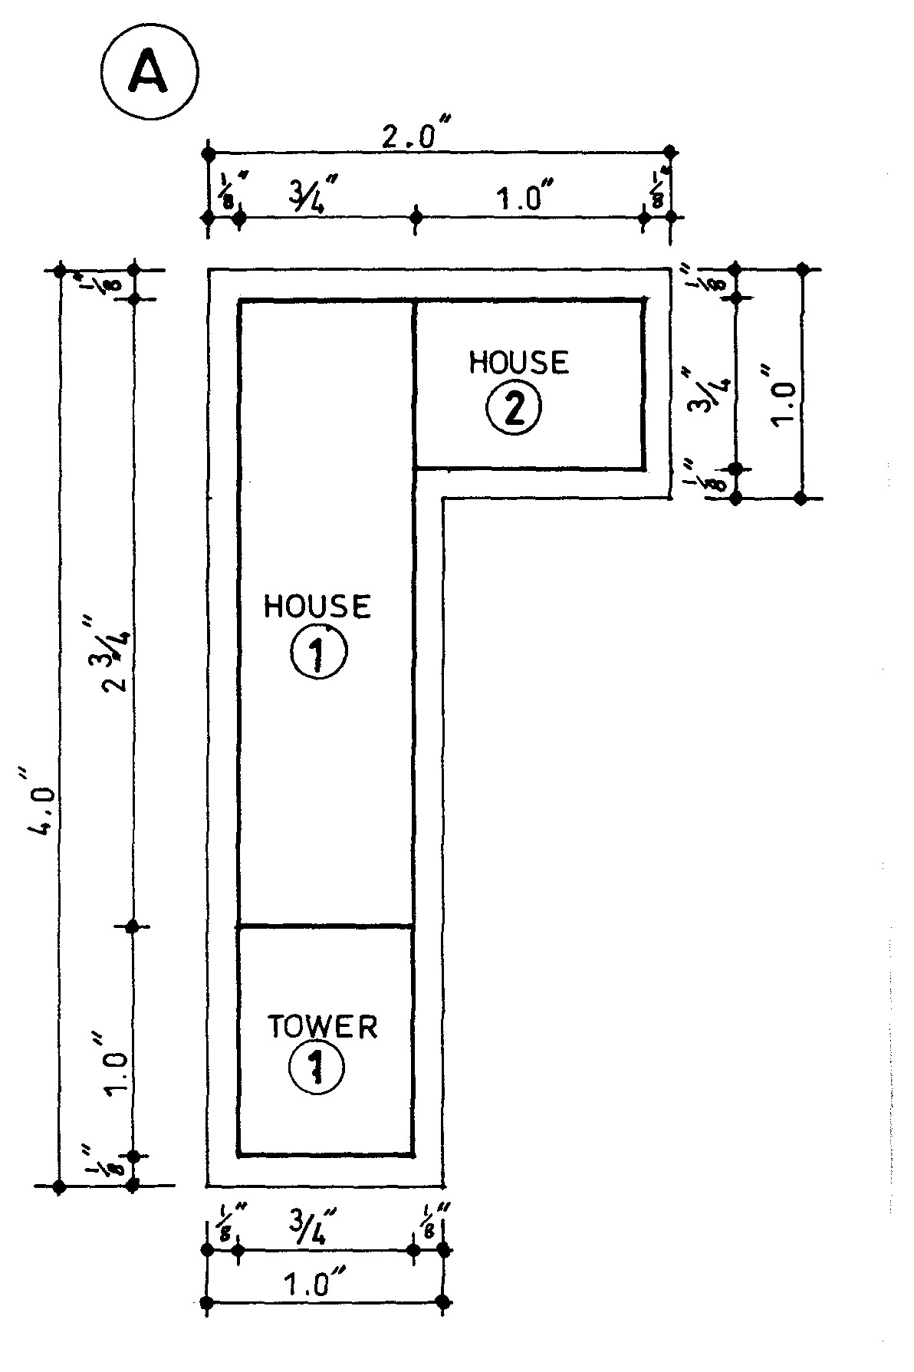

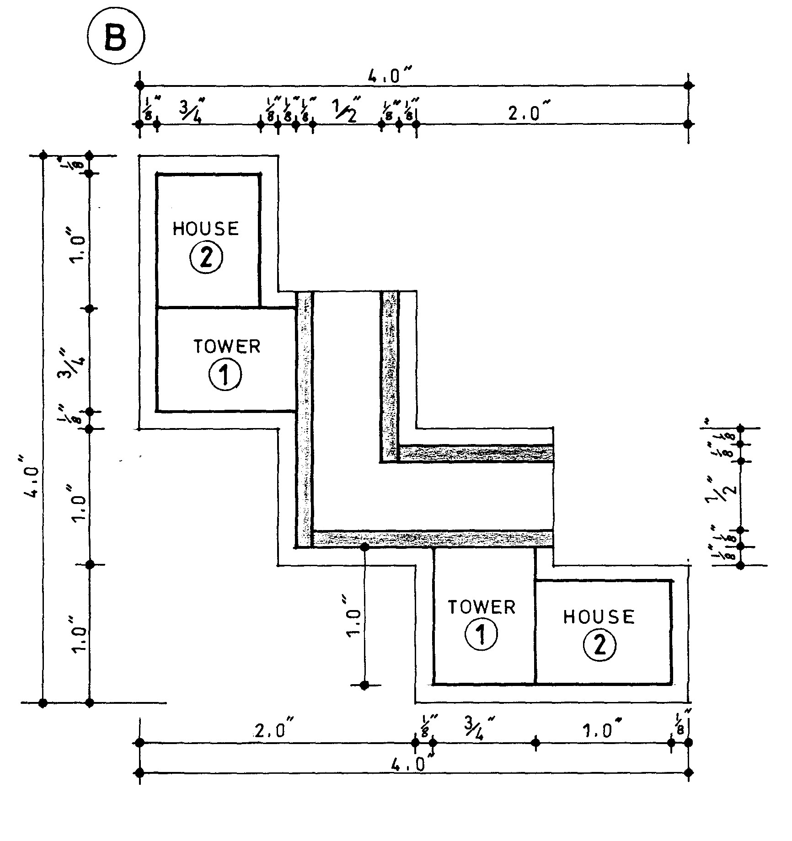

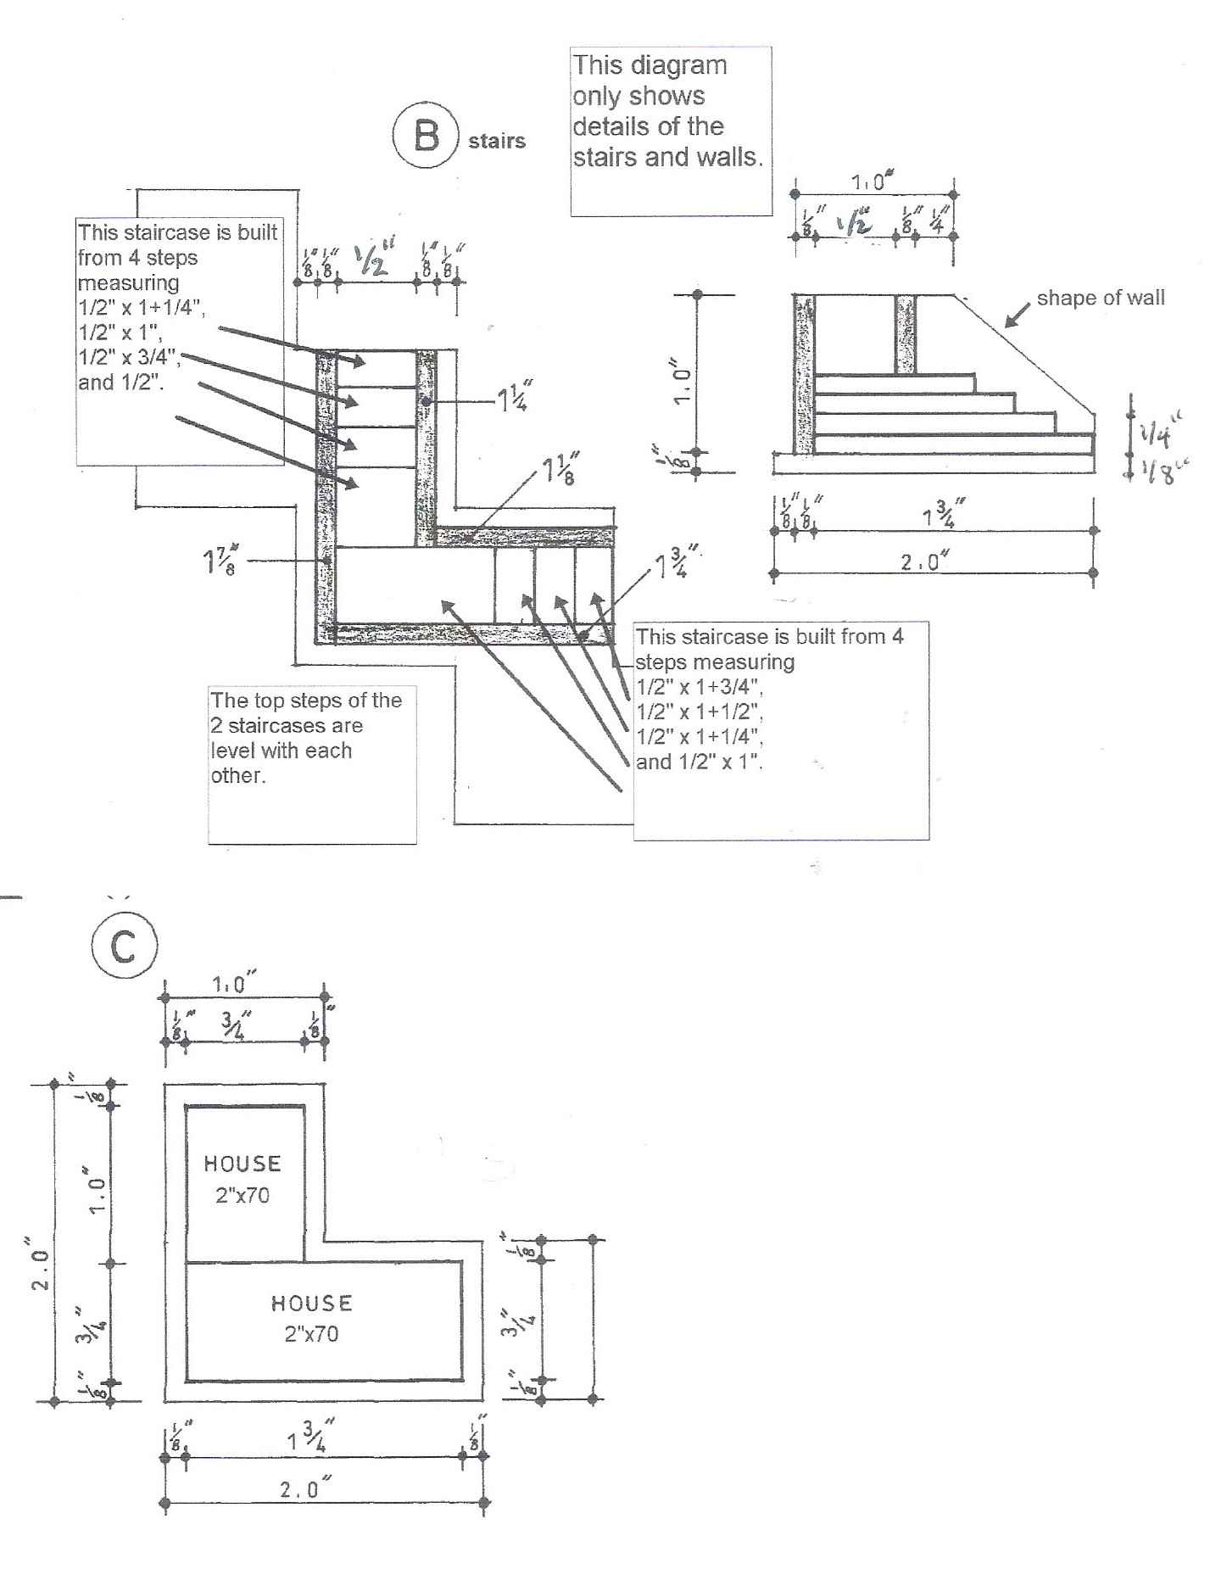

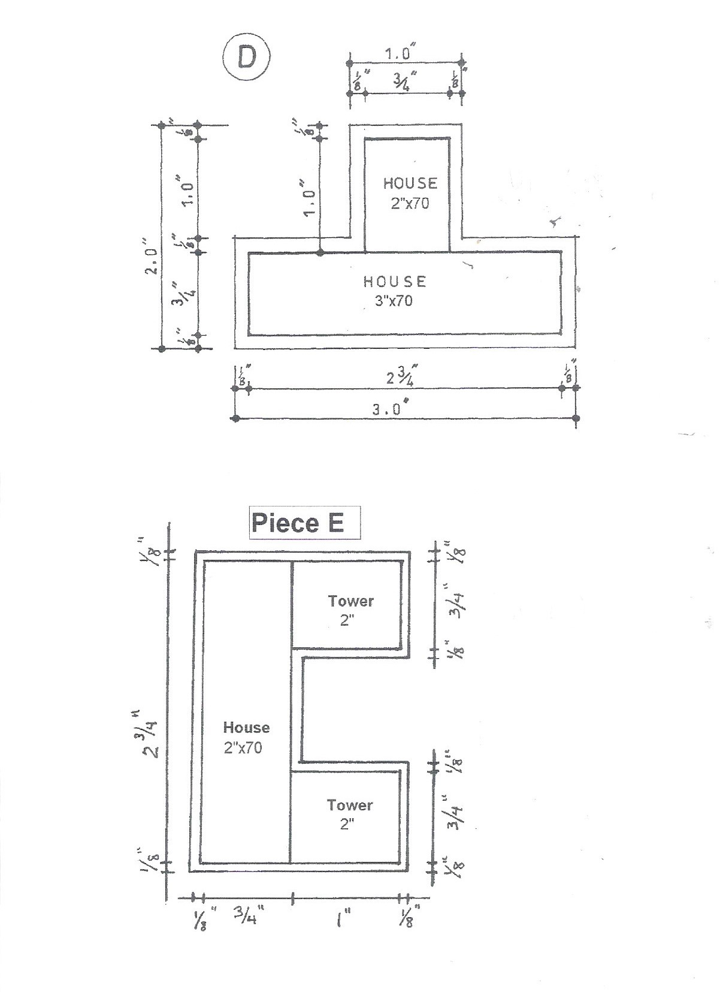

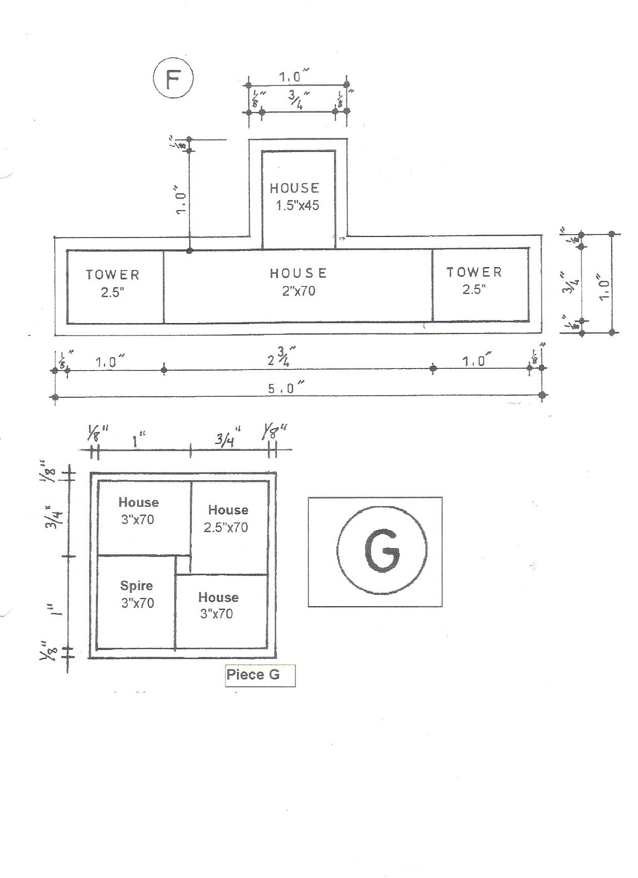
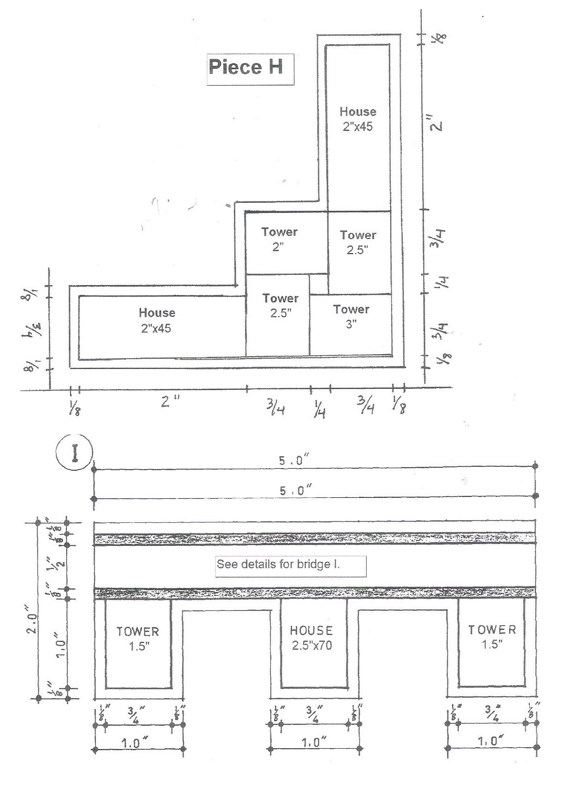
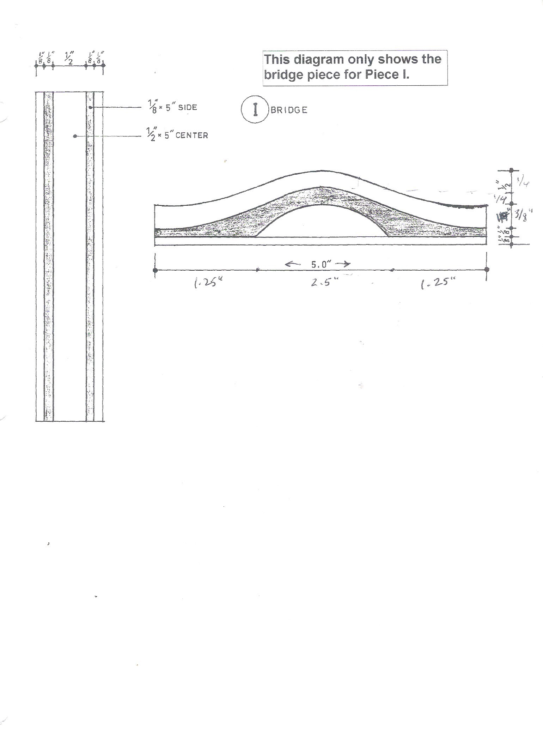
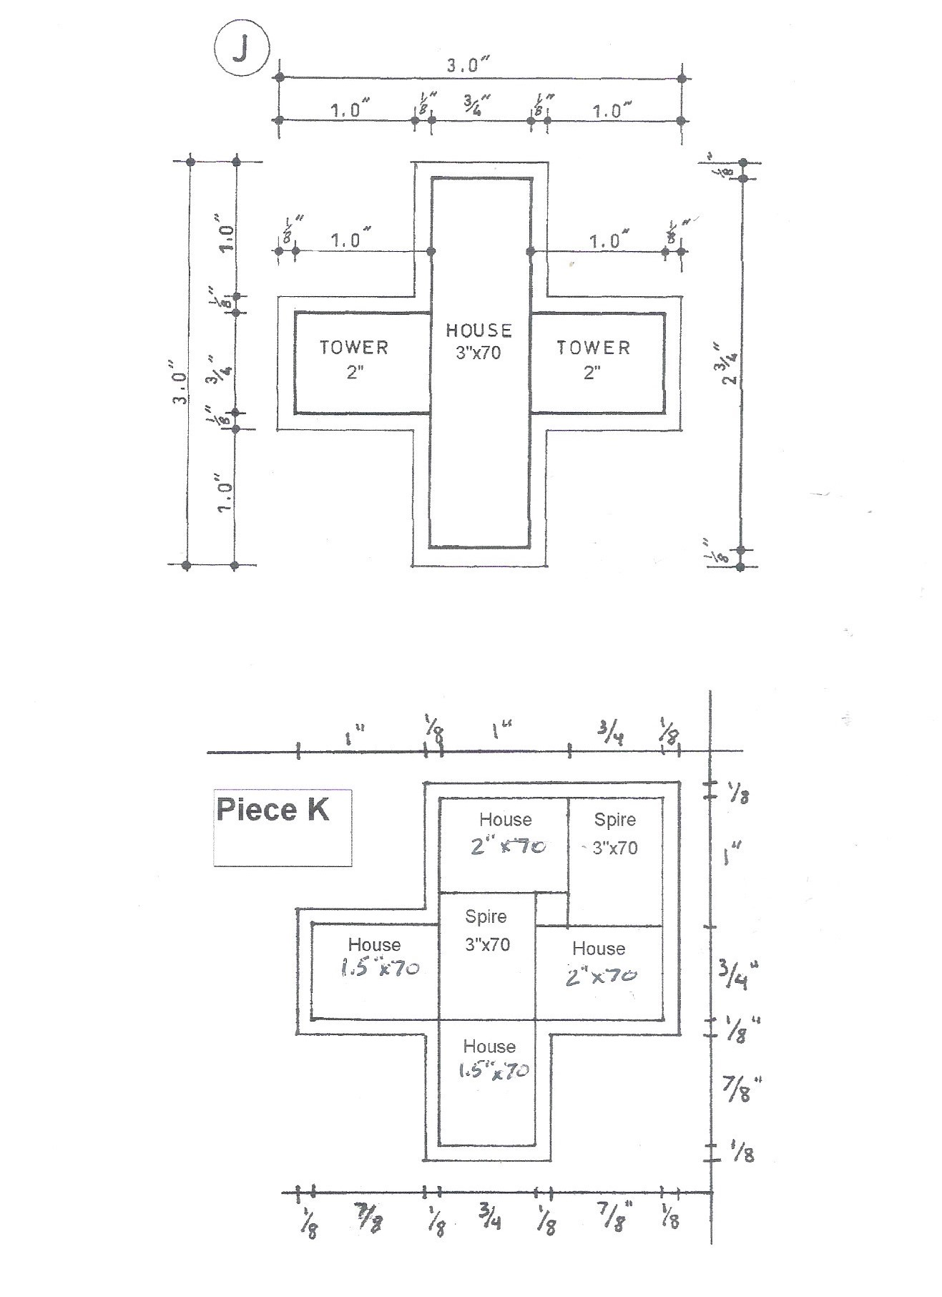
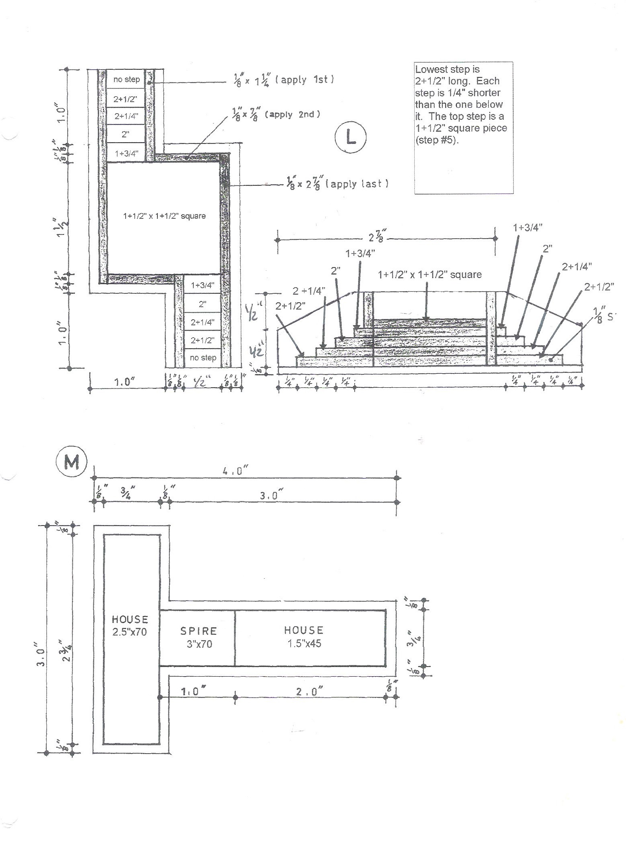
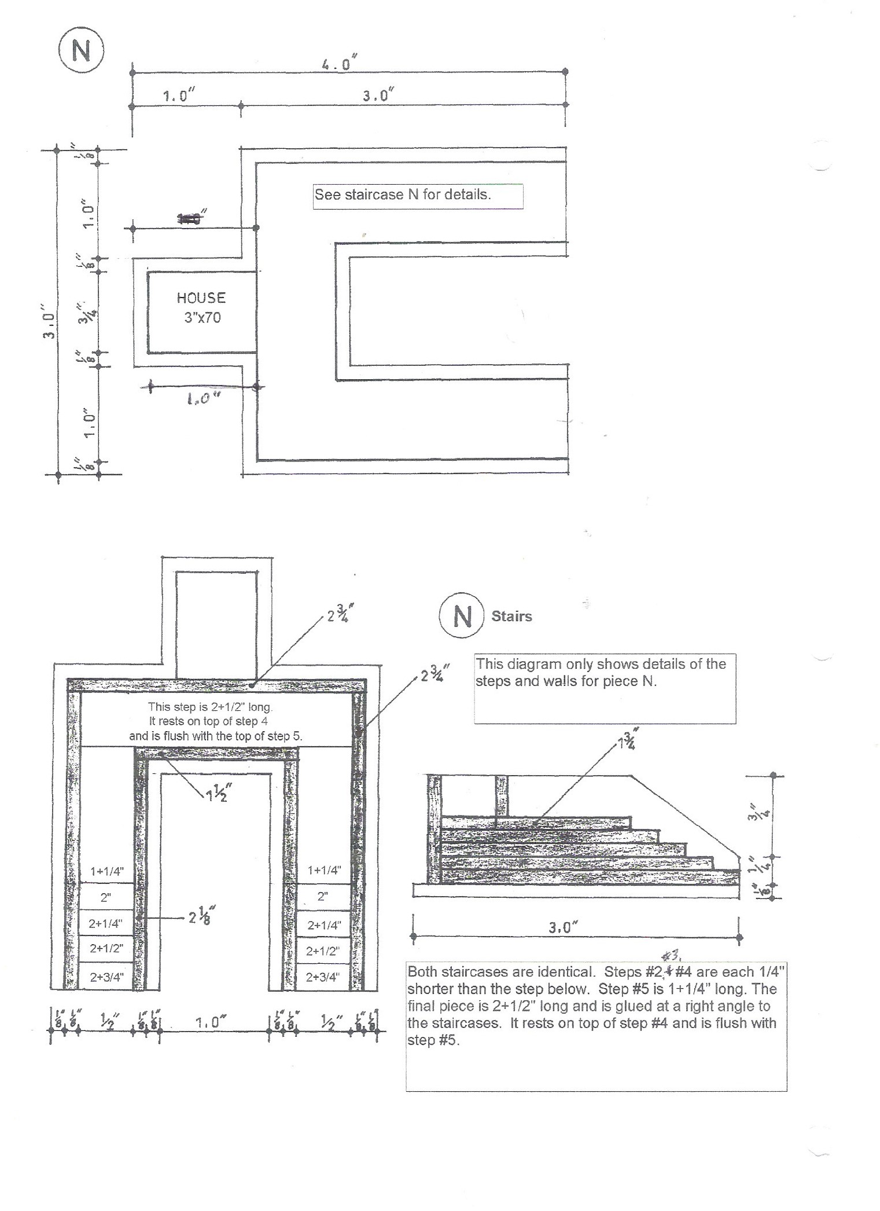
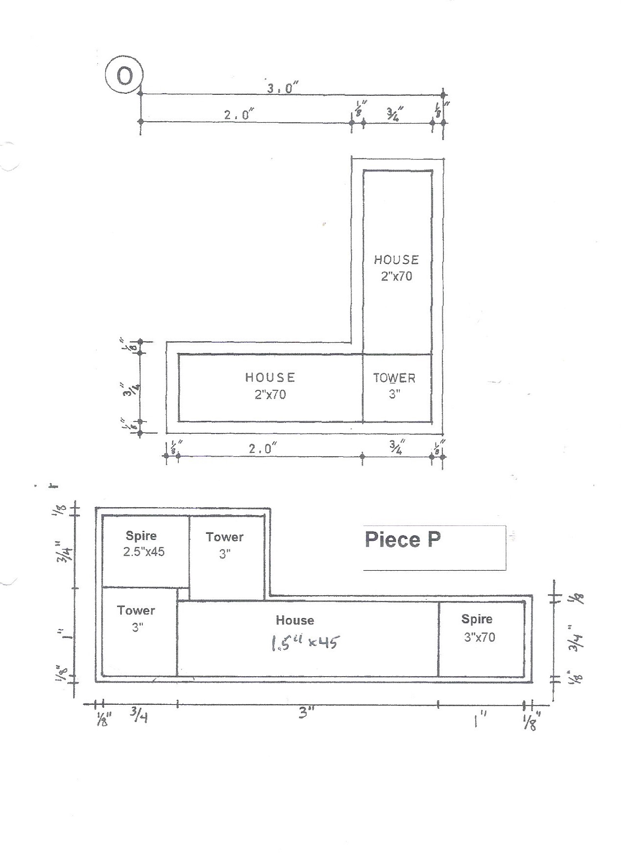
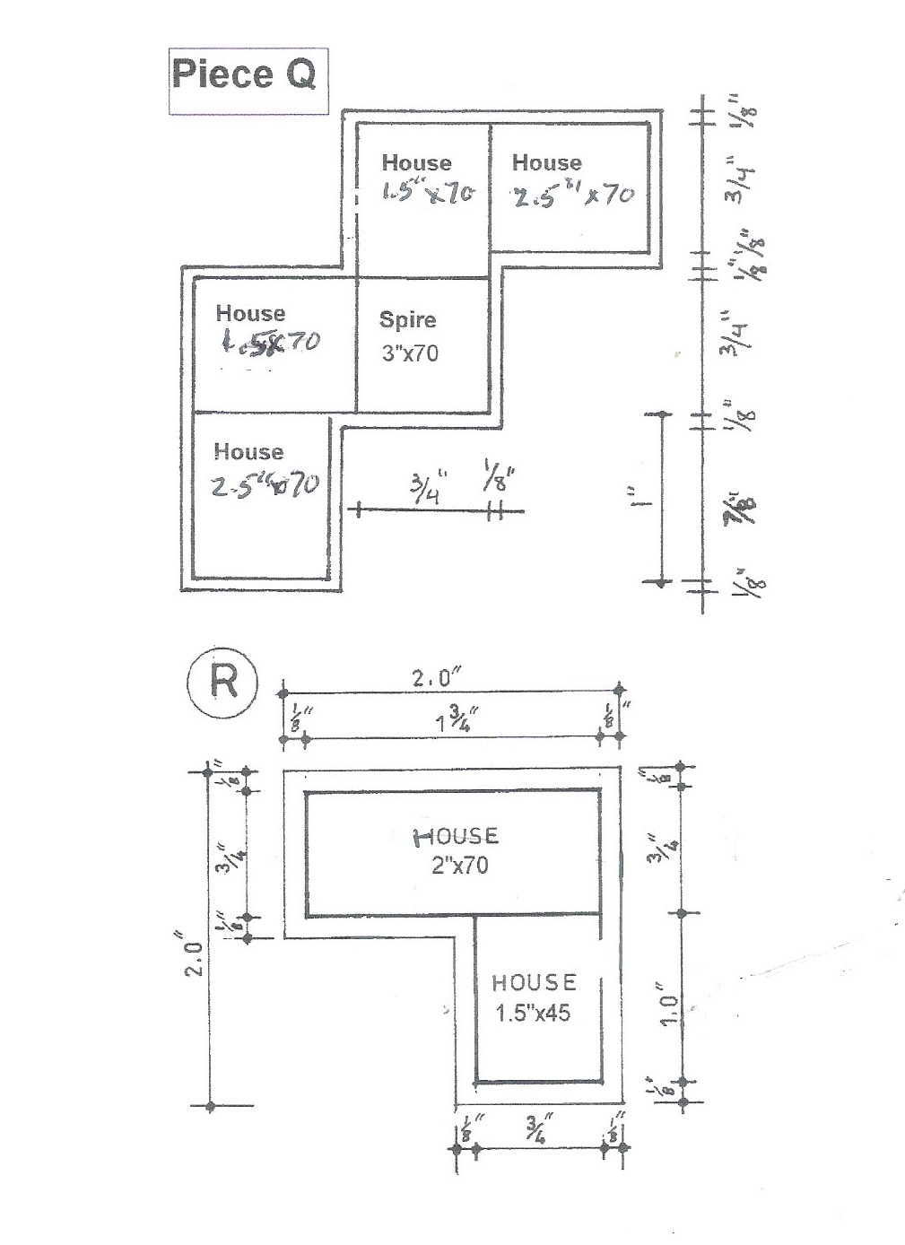
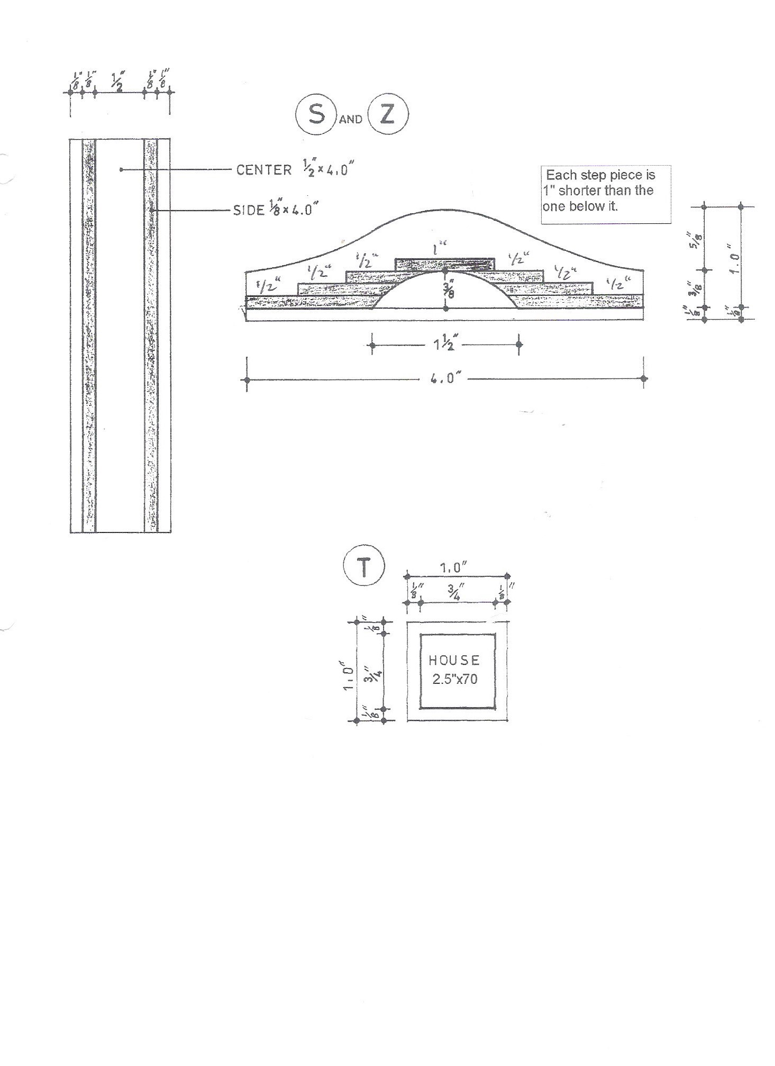
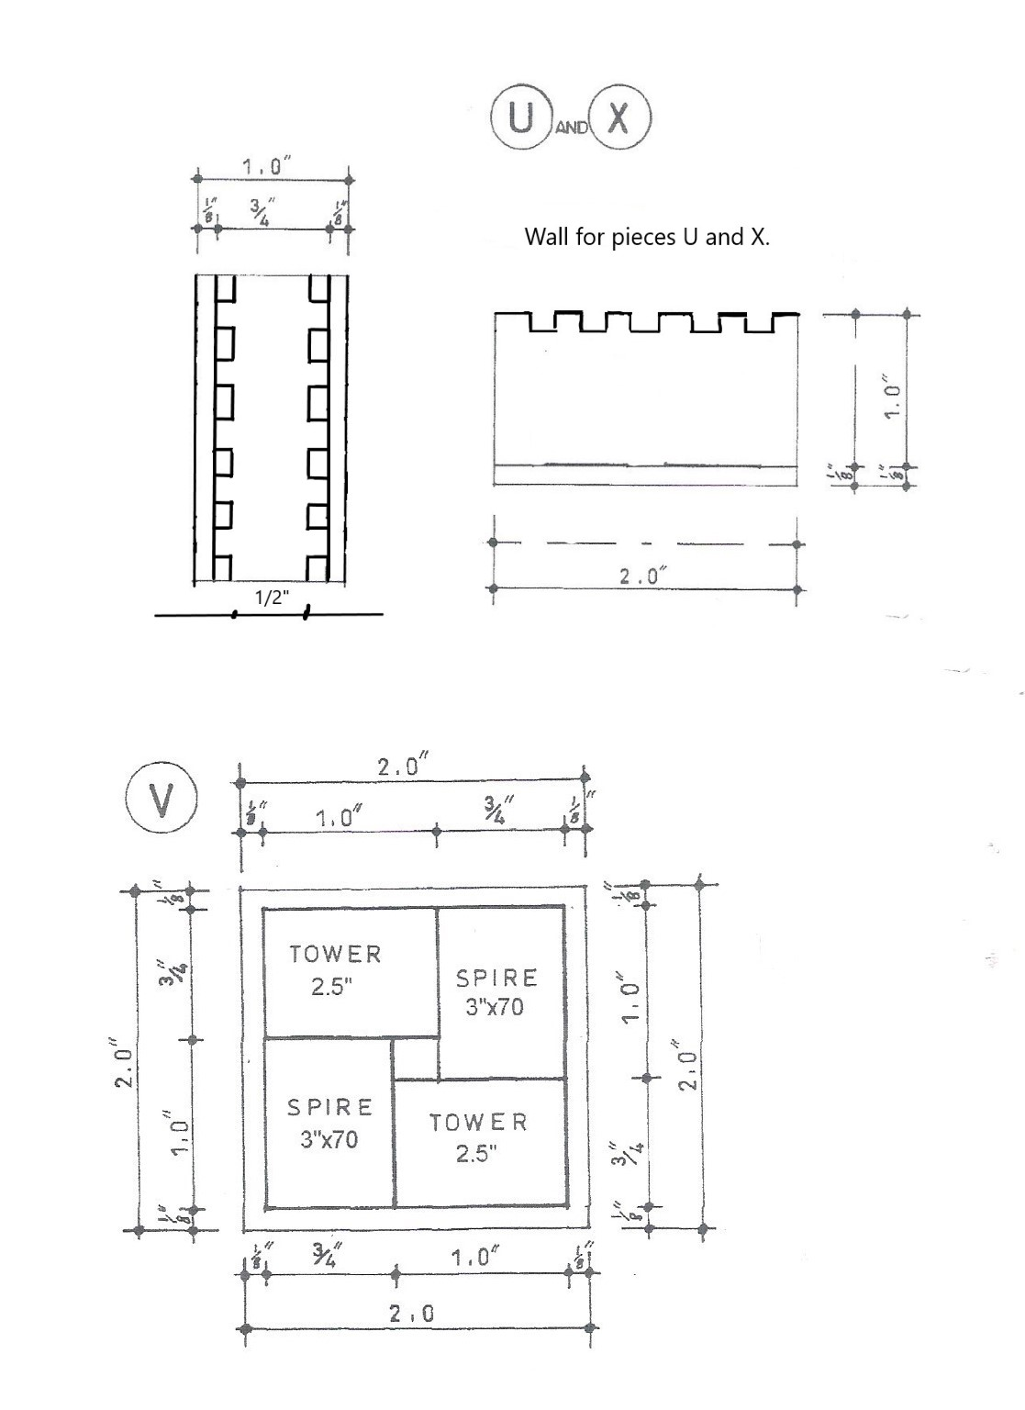
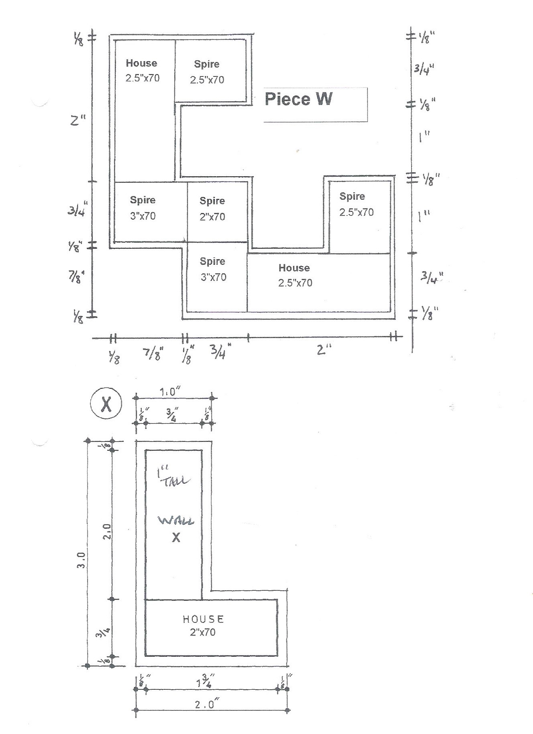
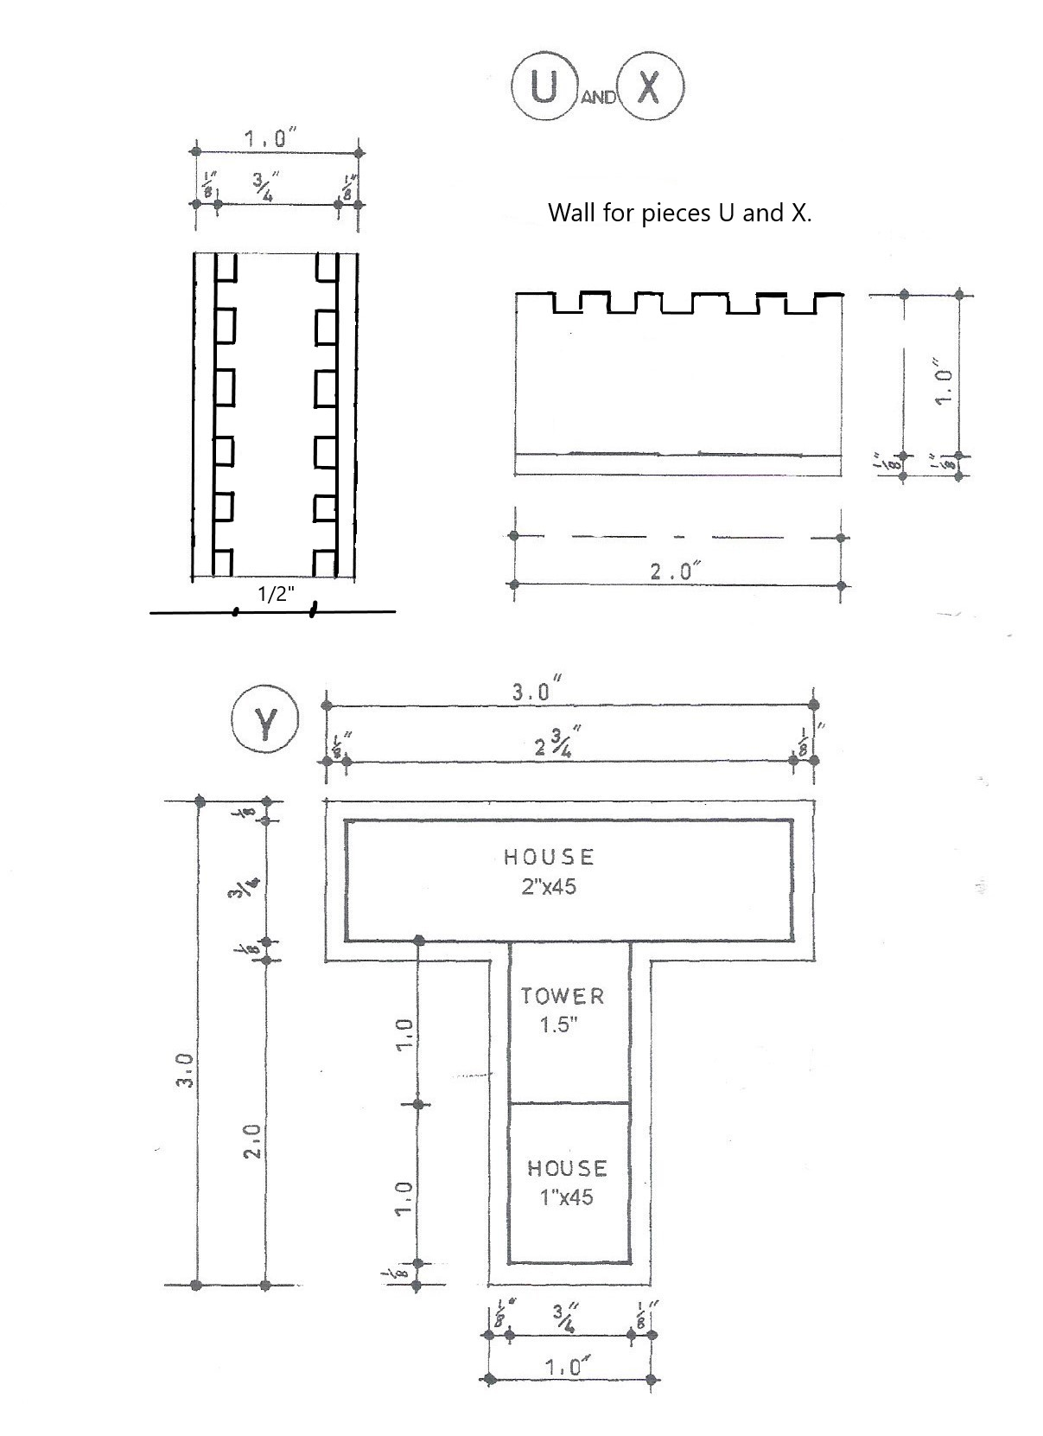

Piece Z is the same as Piece S.


